
COSMETOLOGY SUPPORT
We are here to offer you 4 products for when you reopen for the safety of both you and your valued customer! Including 3-ply disposable masks, disposable gloves, a medical face shield, and 99% naturally derived hand sanitizer. One stop shop for all your needs!
Item | Units | Price
Disposable Nitrile Gloves | 1 Box (50 pairs) | $32.00
Disposable 3-Ply Face Masks | 1 Box (50 units) | $80.00
Face Shield | 1 Face Shield | $8.60
100ml Hand Sanitizer | 1 Unit | $7.00
4L Hand Sanitizer | 1 Unit | $119.00
PACKAGE DEAL!

- 1 Box of 50 pairs of Disposable Gloves
- 1 Box of 50 Disposable Masks
- 1 Face Shield
- 5 bottles of 100ml Hand Sanitizer
Receive this package for $139.99 or 10% savings!
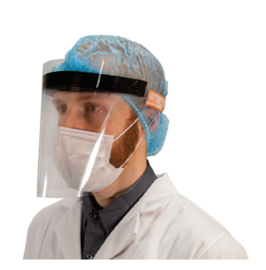
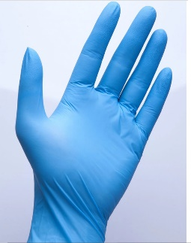



Uniform Works Ltd. Dartmouth, NS B3B 0J5 902-468-5367 info@uniformworks.ca
www.uniformsworks.ca

